## Topic of research

Google maps API

## Purpose of research

To gain a better understanding of how the Google Maps API works and how to incorporate it into the application using android studio.

### What is google maps API?

The Google maps API allows Our team to use Googles navigation services through our application, an API allows online data to be represented through a third-party application. In our case this would be the IWIC application.

### What purpose would the google maps API serve in our application?

The application brief includes the need for directions to the IWIC centre, Using google maps would allow us to give directions through an on-screen route directly to the IWIC centre.

However other uses include:

* We can also provide navigation to events
* Places of interest
* Parking for the IWIC centre
* Keyword search for location e.g. places to eat

### How to we incorporate the API into our application?

As Maps is obviously developed by Google it is supported from within android studio, which is the program we will be using to build this whole application. Furth more we will also need to install the Google Play Services SDK (software development kit).

As the purpose of the maps is to take them to a pre-determined location set by the IWIC team there would be no need for any search functionality from within the application.

The way in which this would be implemented includes a direct link to the navigation screen to a pre-set location which is easy enough done when implementing this through android studio and you can set up a Google maps activity.

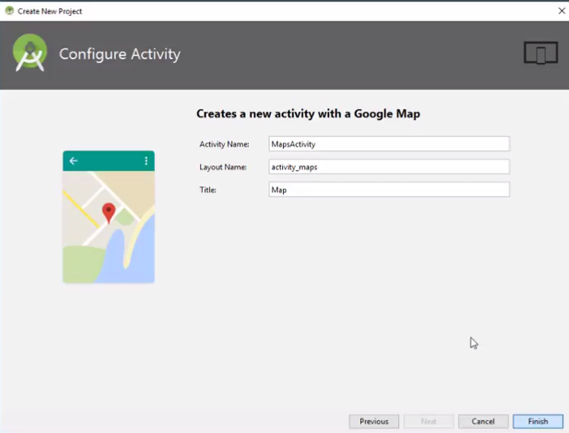

### Google maps key

An API key is what authenticates users to send and receive data from google maps throughout third party application, it ensures the person sending the request is authorised to do so. Furth more this key allows Google to track the number of requests using a specific key to ensure that they are within the allocated tariff.

An API key would need to be brought through the university.

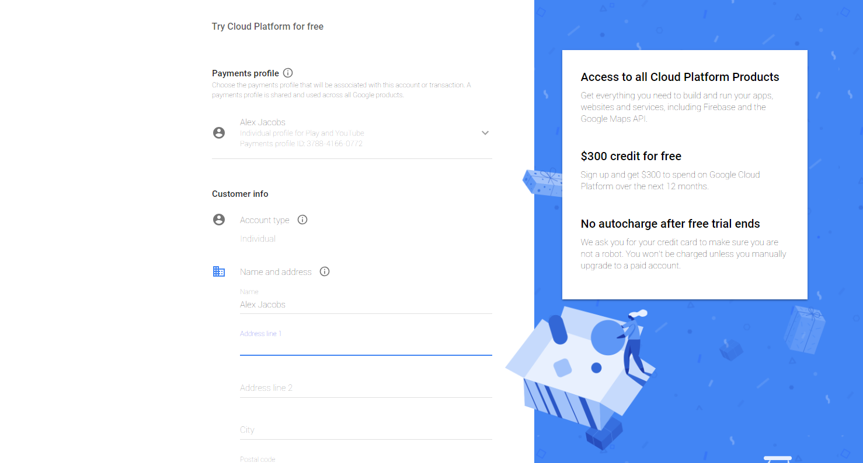

### Pre-determined locations

As the aim of using the maps API is to guide people to set locations we need a method of setting the required location when the map is opened. This is done using latitude and longitude and would be possibly managed through firebase. This would be discovered when we start the development process.

Adding locations to the map should be an easy task which can be carried out in several minutes, so far, the only way I am aware of is to hard code locations into the app using android studio.

If this was to be done by a member of IWIC Staff, it would become a long process for adding a single location to the map.

The next stage of research would be to see if we can add markers to the map using firebase to make the whole interface user friendly.

## Carried out by – Alex Jacobs

Content goes here, please delete upon completion.

## Summary of research

Google Maps can be very easily implemented through android studio, however there are limitations using an API key of 25,000 searches per day for free which should be plenty enough for IWIC.

The next stage is finding a way to add markers from a CMS e.g. firebase which would make it easy for IWIC to mark locations when they are added the events page within the application.